Activity 10 – A new Pier - The Pier as a liner!
This worksheet has been developed to supplement Activity 8.
Read carefully the article about Lawrence Fuller’s plans in 1976 to develop Worthing Pier.
Do you think that your parents and grandparents liked and supported this idea?
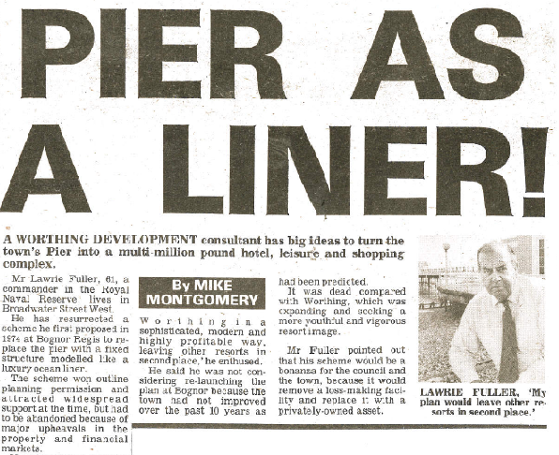

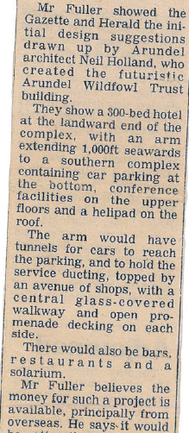

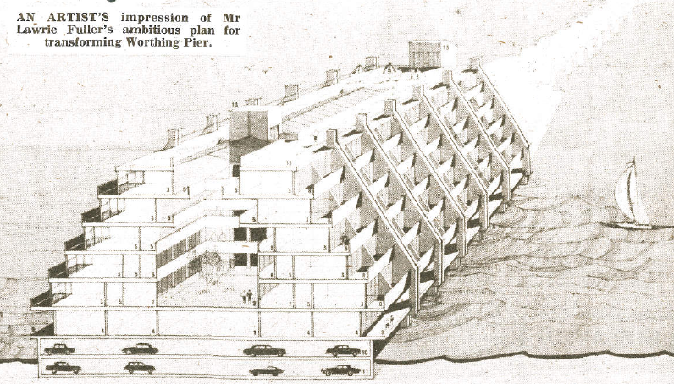

Activity: You are a member of the Adur & Worthing District Council Planning Department.

If the plan to develop the Liner was resubmitted today would you endorse or oppose the application? Write a persuasive letter clearly stating your reasons why this proposal should or should not receive support.

